Terraform Task

Task Description:

Launch Linux EC2 instances in two regions using a single Terraform file.

Techstacks needs to be used :
- AWS EC2
- Terraform
- AWS CLI
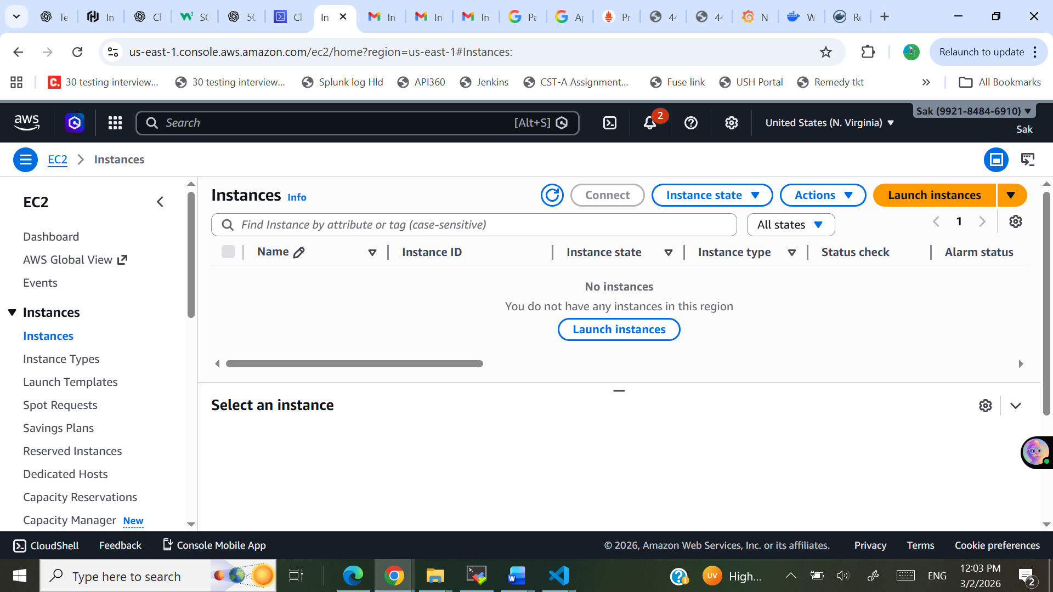

provider "aws" {
alias = "useast"
region = "us-east-1"
}
provider "aws" {
alias = "mumbai"
region = "ap-south-1"
}
resource "aws_vpc" "vpc_useast" {
provider = aws.useast
cidr_block = "10.0.0.0/16"

tags = { Name = "USEast-VPC" }
}

resource "aws_subnet" "subnet_useast" {
provider = aws.useast
vpc_id = aws_vpc.vpc_useast.id
cidr_block = "10.0.1.0/24"
availability_zone = "us-east-1a"

tags = { Name = "USEast-Subnet" }
}

resource "aws_internet_gateway" "igw_useast" {
provider = aws.useast
vpc_id = aws_vpc.vpc_useast.id

tags = { Name = "USEast-IGW" }
}

resource "aws_route_table" "rt_useast" {
provider = aws.useast
vpc_id = aws_vpc.vpc_useast.id

route {
cidr_block = "0.0.0.0/0"
gateway_id = aws_internet_gateway.igw_useast.id
}

tags = { Name = "USEast-RT" }
}

resource "aws_route_table_association" "rta_useast" {
provider = aws.useast
subnet_id = aws_subnet.subnet_useast.id
route_table_id = aws_route_table.rt_useast.id
}

resource "aws_security_group" "sg_useast" {
provider = aws.useast
vpc_id = aws_vpc.vpc_useast.id

ingress {
from_port = 22
to_port = 22
protocol = "tcp"
cidr_blocks = ["0.0.0.0/0"]
}

ingress {
from_port = 80
to_port = 80
protocol = "tcp"
cidr_blocks = ["0.0.0.0/0"]
}

egress {
from_port = 0
to_port = 0
protocol = "-1"
cidr_blocks = ["0.0.0.0/0"]
}

tags = { Name = "USEast-SG" }
}

resource "aws_instance" "instance_useast" {
provider = aws.useast
ami = "ami-0f3caa1cf4417e51b"
instance_type = "t3.micro"
subnet_id = aws_subnet.subnet_useast.id
vpc_security_group_ids = [aws_security_group.sg_useast.id]
associate_public_ip_address = true
tags = { Name = "USEast-Instance" }
}
resource "aws_vpc" "vpc_mumbai" {
provider = aws.mumbai
cidr_block = "10.1.0.0/16"

tags = {
Name = "Mumbai-VPC"
}
}

resource "aws_subnet" "subnet_mumbai" {
provider = aws.mumbai
vpc_id = aws_vpc.vpc_mumbai.id
cidr_block = "10.1.1.0/24"
availability_zone = "ap-south-1a"

tags = {
Name = "Mumbai-Subnet"
}
}

resource "aws_internet_gateway" "igw_mumbai" {
provider = aws.mumbai
vpc_id = aws_vpc.vpc_mumbai.id

tags = {
Name = "Mumbai-IGW"
}
}

resource "aws_route_table" "rt_mumbai" {
provider = aws.mumbai
vpc_id = aws_vpc.vpc_mumbai.id

route {
cidr_block = "0.0.0.0/0"
gateway_id = aws_internet_gateway.igw_mumbai.id
}

tags = {
Name = "Mumbai-RT"
}
}

resource "aws_route_table_association" "rta_mumbai" {
provider = aws.mumbai
subnet_id = aws_subnet.subnet_mumbai.id
route_table_id = aws_route_table.rt_mumbai.id
}

resource "aws_security_group" "sg_mumbai" {
provider = aws.mumbai
vpc_id = aws_vpc.vpc_mumbai.id

ingress {
from_port = 22
to_port = 22
protocol = "tcp"
cidr_blocks = ["0.0.0.0/0"]
}

ingress {
from_port = 80
to_port = 80
protocol = "tcp"
cidr_blocks = ["0.0.0.0/0"]
}

egress {
from_port = 0
to_port = 0
protocol = "-1"
cidr_blocks = ["0.0.0.0/0"]
}

tags = {
Name = "Mumbai-SG"
}
}

resource "aws_instance" "instance_mumbai" {
provider = aws.mumbai
ami = "ami-0f5ee92e2d63afc18"
instance_type = "t3.micro"
subnet_id = aws_subnet.subnet_mumbai.id
vpc_security_group_ids = [aws_security_group.sg_mumbai.id]
associate_public_ip_address = true
tags = {
Name = "Mumbai-Instance"
}
}

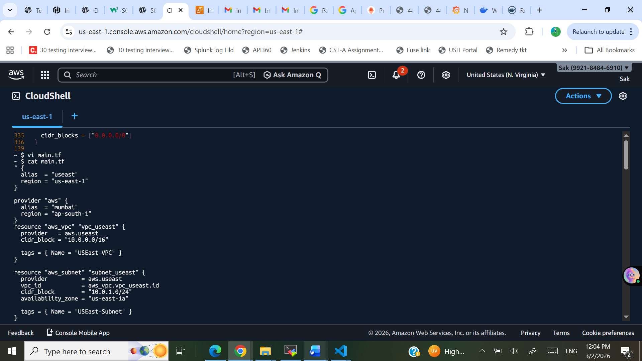
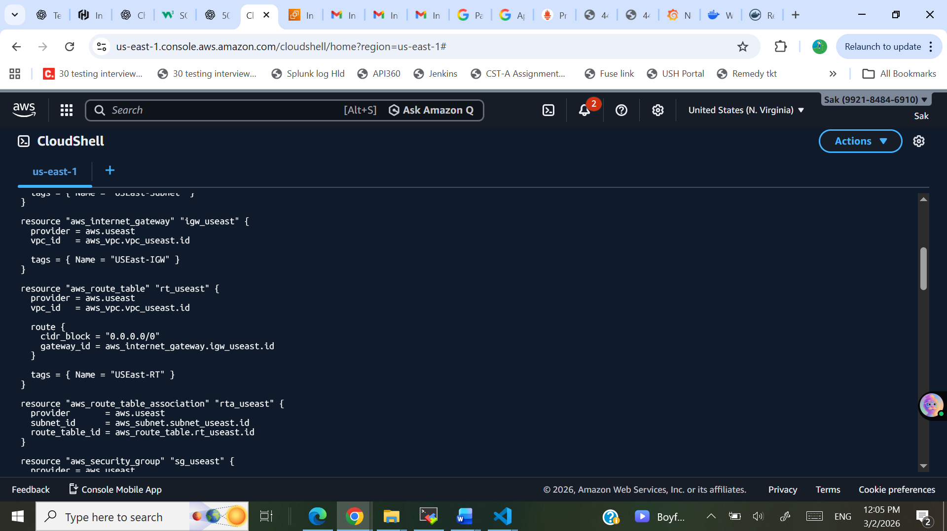

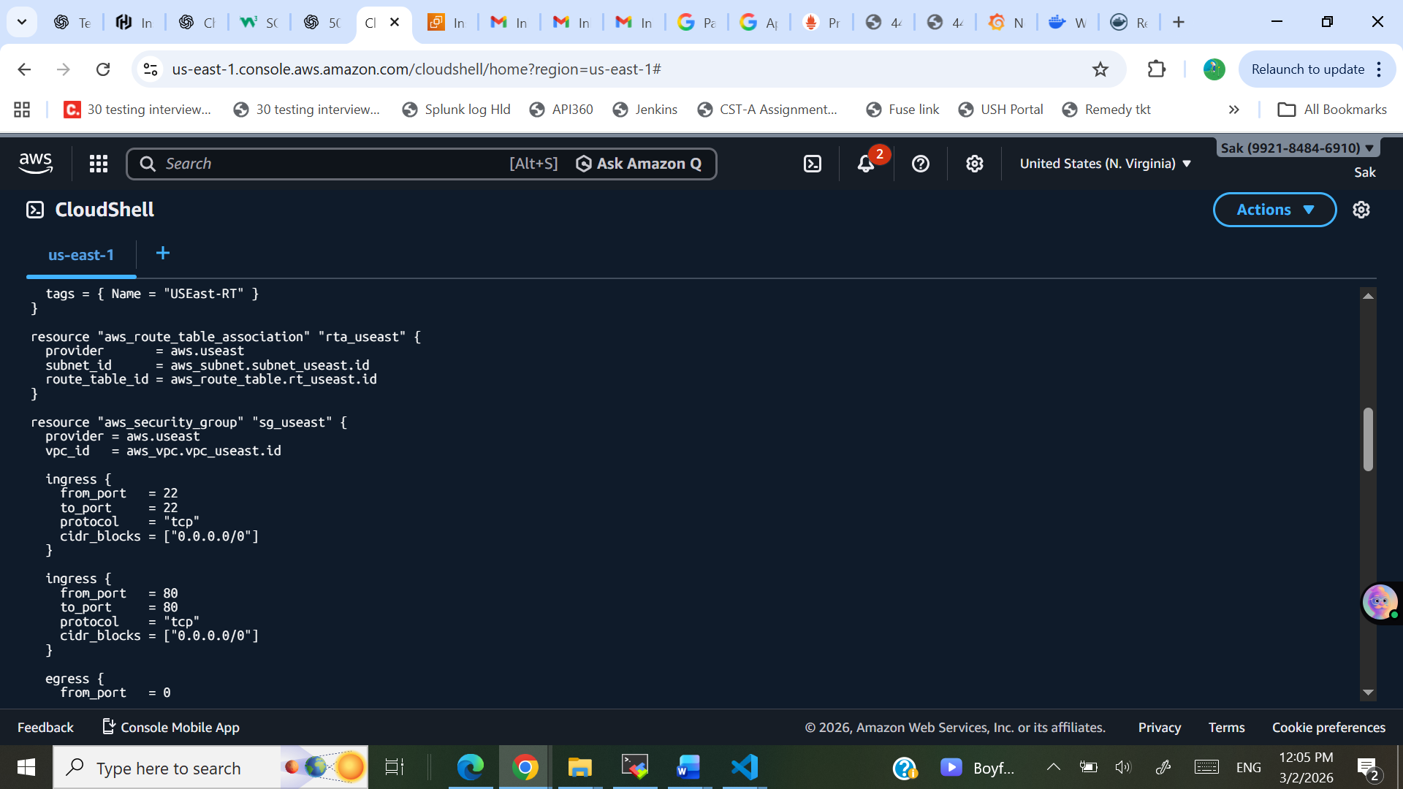
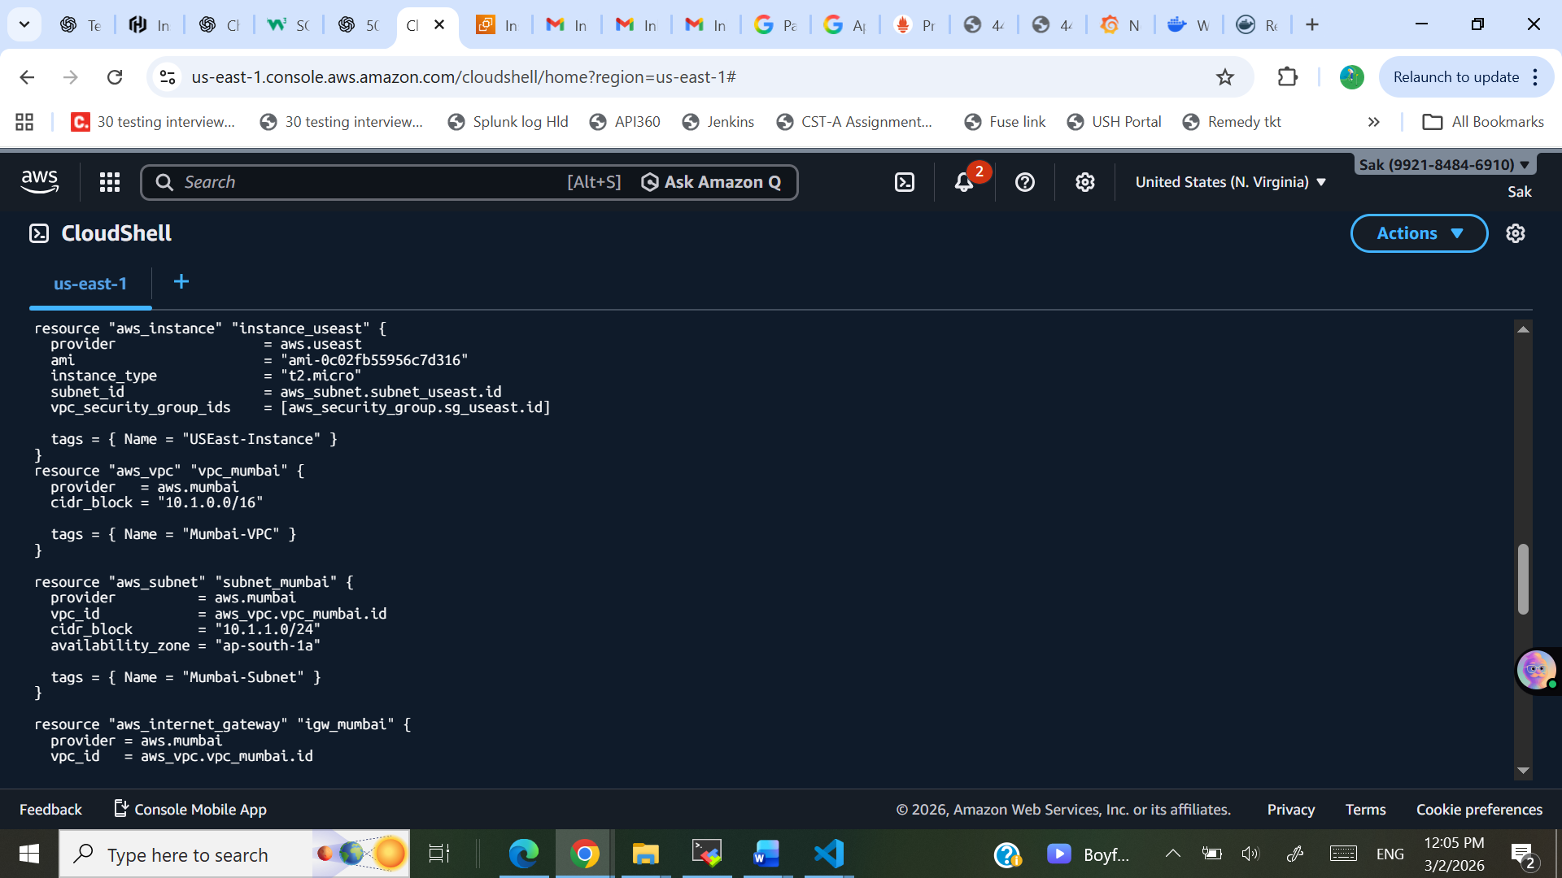
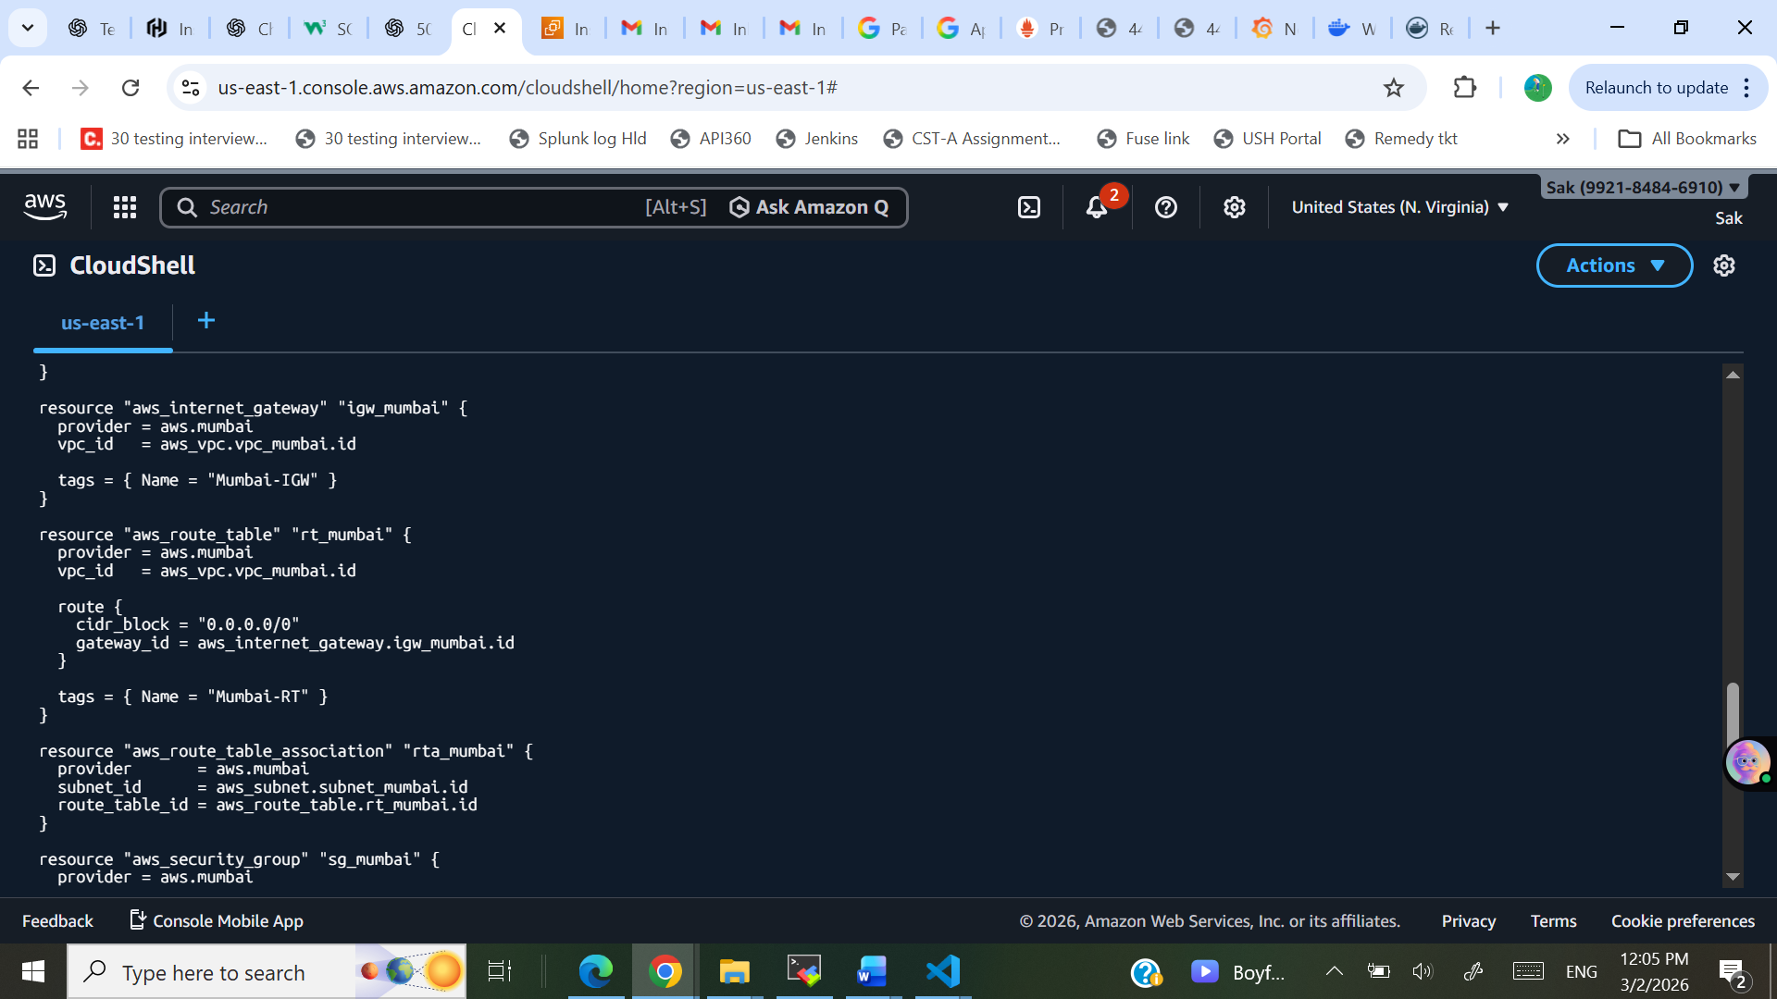
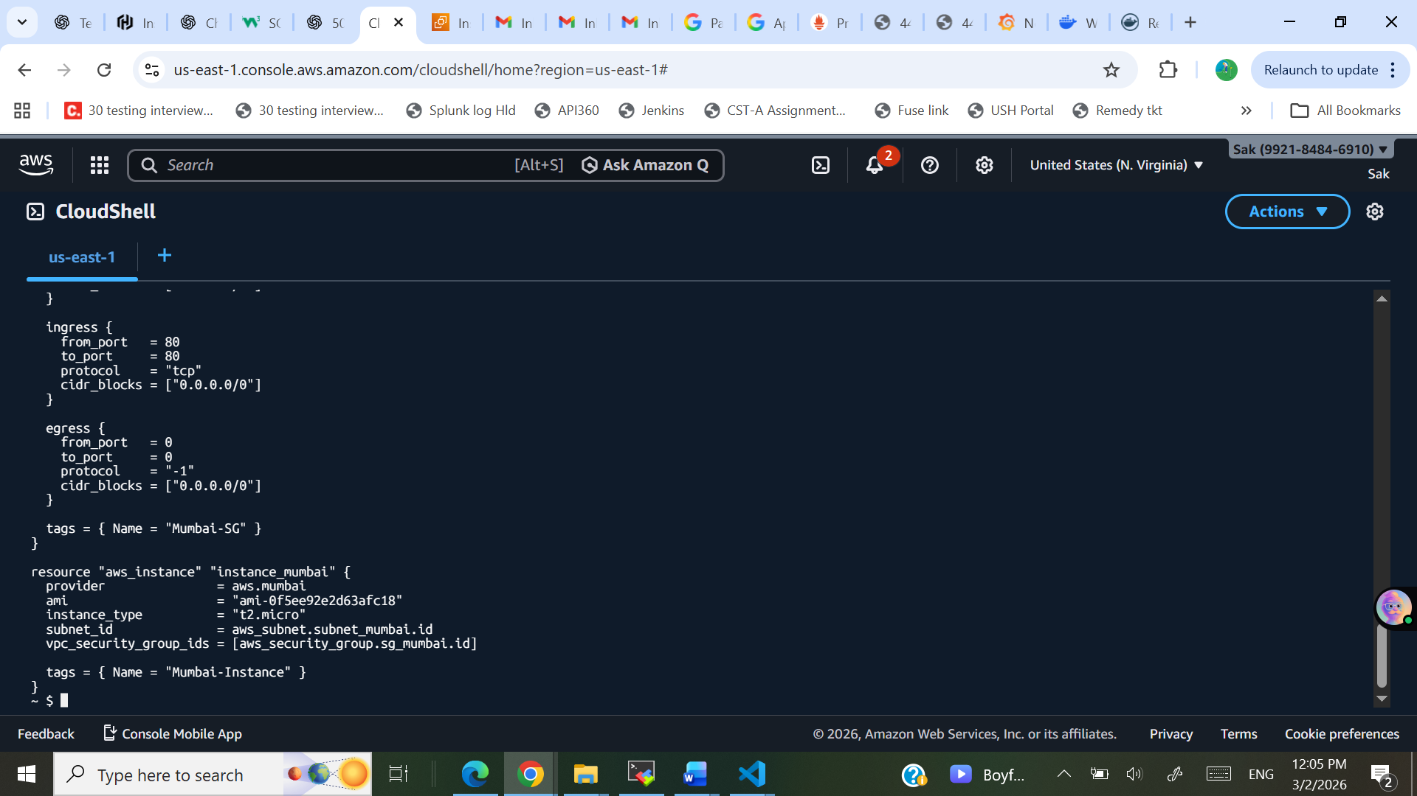

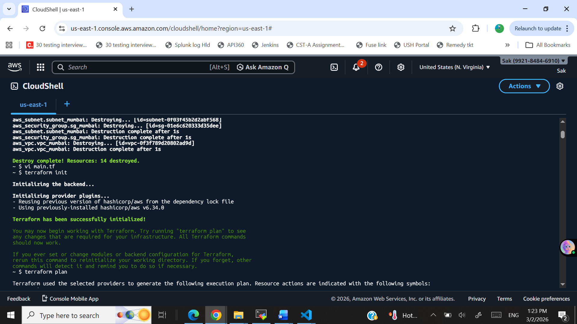
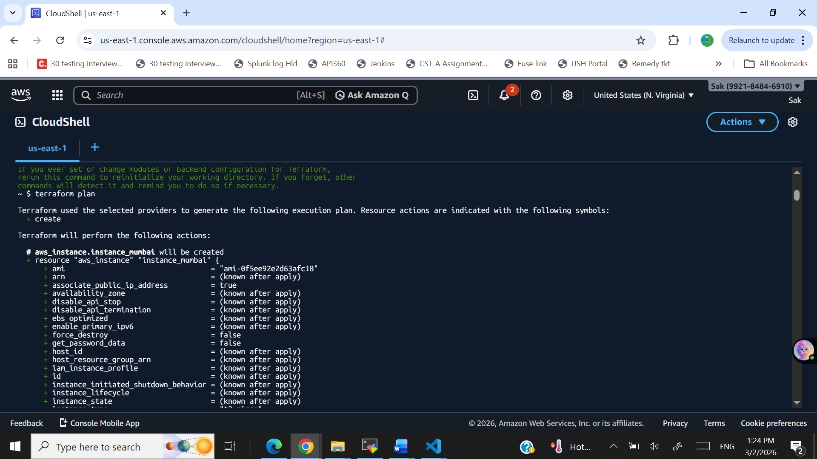
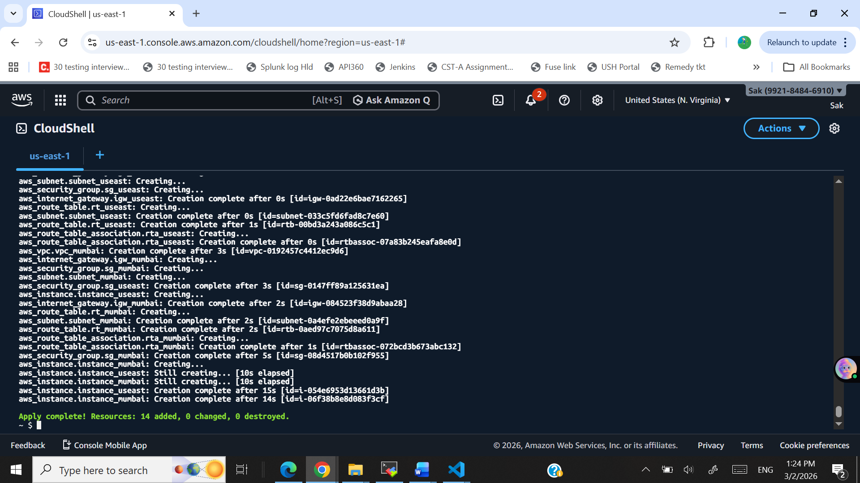

Two Instances Created in Two different Region:
Mumbai:
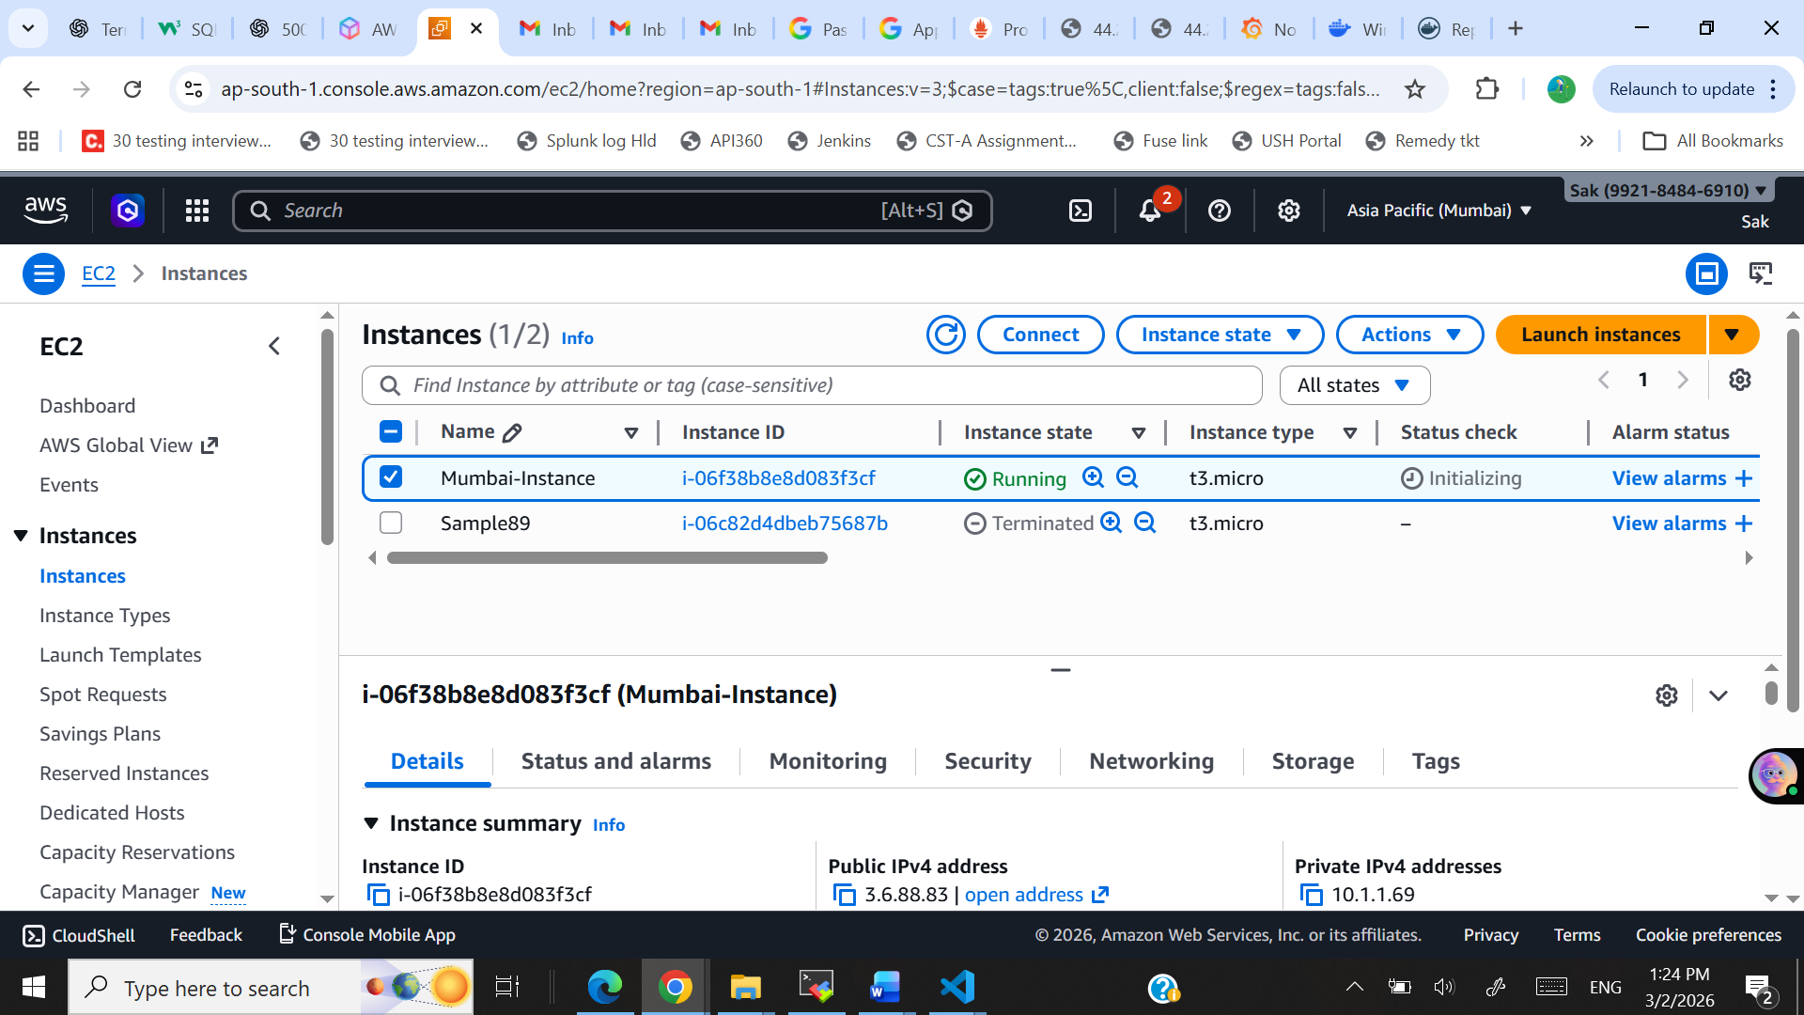
Virginia:
